# **Methods of Internet Connection**

There are various ways of connecting to the internet. All of which require a small network of your own, known as a LAN or Local Area Network. This is the network of all devices in your house connected vie cable (RJ45 / Ethernet) or by Wireless technology with the use of built in or external wireless network cards connecting to your network router. Your router in most local domestic uses will act as the modem, Ethernet switch and router all in one to allow the ISP or your network and T.V provider to offer internet packages at more convenient price ranges, where as in a small business or office setup your router would be its own computer carrying out its necessary tasks and then have separate repeaters, bridges and switches to provide internet access to separate branches of the building and if needed a wireless access point to allow wireless connectivity to the network also.

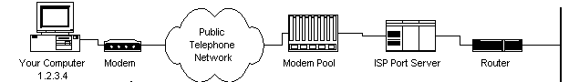

## **Wired**

Wired connection to the internet is the older but yet still more reliable way to get online or surf the internet. Which is why a lot of offices, educational buildings such as colleges etc. all use wired it also tends to be the more favoured choice for people who play online gaming, since its not capped to the 54Mbps that the majority of Wi-Fi cards are capable of whereas Ethernet(Wired) can go up to Gigabit (1000Mbps) speeds it all depends on the Cable and sometimes the Ethernet port technology but these days it’s rare to find an Ethernet port that has capabilities less than a minimum of 100Mbps which is still double Wi-Fi.

Wired connections are pretty straight forward and “Plug & Play”, you get an Ethernet cable and plug one end into your PC, Gaming console or even your T.V and the other end into your Router or Modem and there you go a speedy connection to the internet is formed.

## **Wireless**

Wireless is a more modern and popular way to connect among Mobile device users such as laptops, Smartphones iPods, etc. wireless is achieved by having a wired connection into the wireless access point which then takes the internet connection brought to it by the Ethernet cable, DSL or phone line and spreads it out for anyone to wirelessly connect to that internet connection with the use of its set up security password.

[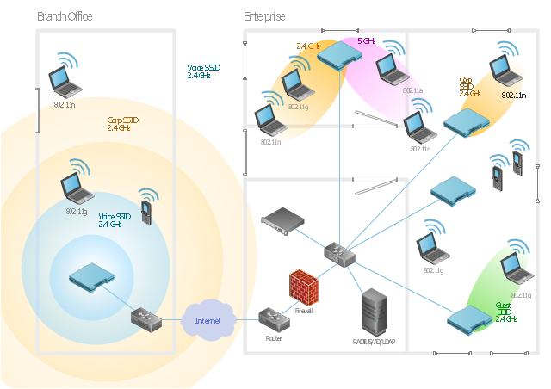](https://conceptdraw.com/a863c3/preview/640)

## **Mobile Connections**

Modern technology is rapidly evolving and so is the way they stay in contact. Modern mobile networks use their infrastructure over what’s called cellular bands which are certain frequencies each mobile operator works on. And go for millions and even billions of euros. In early 2000’s 3g was the new craze where now you could roam the internet from anywhere you have phone signal, yes it was obviously slower than your internet at home but that was rapidly improved upon and got faster and now today we’ve even better newer technology called LTE or 4G which give blazingly fast speed to users anywhere they are not connected to a public Wi-Fi hotspot or on the road travelling.[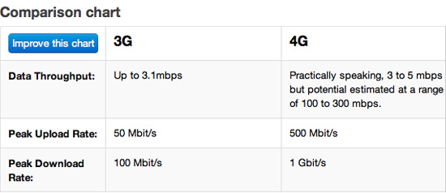](http://www.itrw.net/michigan_it_provider/3g_vs_4g_is_it_worth_it)

As clearly show by the diagram it clearly shows the improvement on speeds.